AE 462
DESIGN OF AEROSPACE STRUCTURES

TERM PROJECT

MINIMUM WEIGHT FIGHTER WING DESIGN AND ANALYSIS

1-Project Description

In the project, the students are asked to design F-16 fighter wing structure. The internal spar and rib configuration of the aircraft is provided. Students are expected to size the structural members (wing skin, spar web, spar flanges, rib web/flanges) based on the 9g loading distribution calculated based on the Schrenk distribution that is obtained as the first part of the project.

The design will be judged based on the total structural weight, design with the least weight being considered the winner from a competitive standpoint. You should make sure that you do not have any calculation mistake in your analyses. Additional considerations affecting the project grade are:

- Credibility or reasonables of your design from a manufacturing standpoint
- The technical approach taken
- Structural solutions developed to meet the various design constraints

The class will be divided into two or at most three-member design teams, with each member being responsible for different tasks. It is the responsibility of the team to divide the work load evenly. The team members are jointly responsible for the overall design. It is important that each member of your team participates fully for your design to be successful.

The final report is due to the June 13, Thursday until 17.00. Project presentations will be on June 14 Friday. The exact time will be announced later on. Final report should be submitted as a complete document with the team members identified on the cover page of the report. The report should be organized into sections according to the main analysis and design tasks performed as required by the project specifications. Reports should be typed, no handwritten reports will be accepted. Reports should be submitted in pdf format. No hardcopy is required !!.

2-Analysis Tools

Each team is responsible for performing load calculation and structural analysis to carry out the calculations in order to substantiate that the wing has the sufficient structural integrity with minimum weight penalty. It is strongly recommended that the programs be written such that design iterations can be carried out without requiring laborious hand calculations.

3-Design Objective

The objective is to design a suitable primary structure of least possible weight for the uniform cantilever wing shown in Figure 1. Figure 1(a) shows the spar/rib layout and the torque box of the actual wing, and Fig. 1(b) shows the simplified spar/rib layout and the torque box of the F-16 wing. In the simplified wing structure, the root region which contains the tension fittings for the wing root joints is not included. Figure 2 shows the detailed internal structural lay-out of the F-16 wing which shows the tension fittings clearly.

Region which contains tension fittings for the wing root joints
Trailing edge
Spars
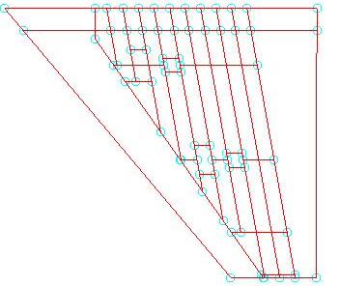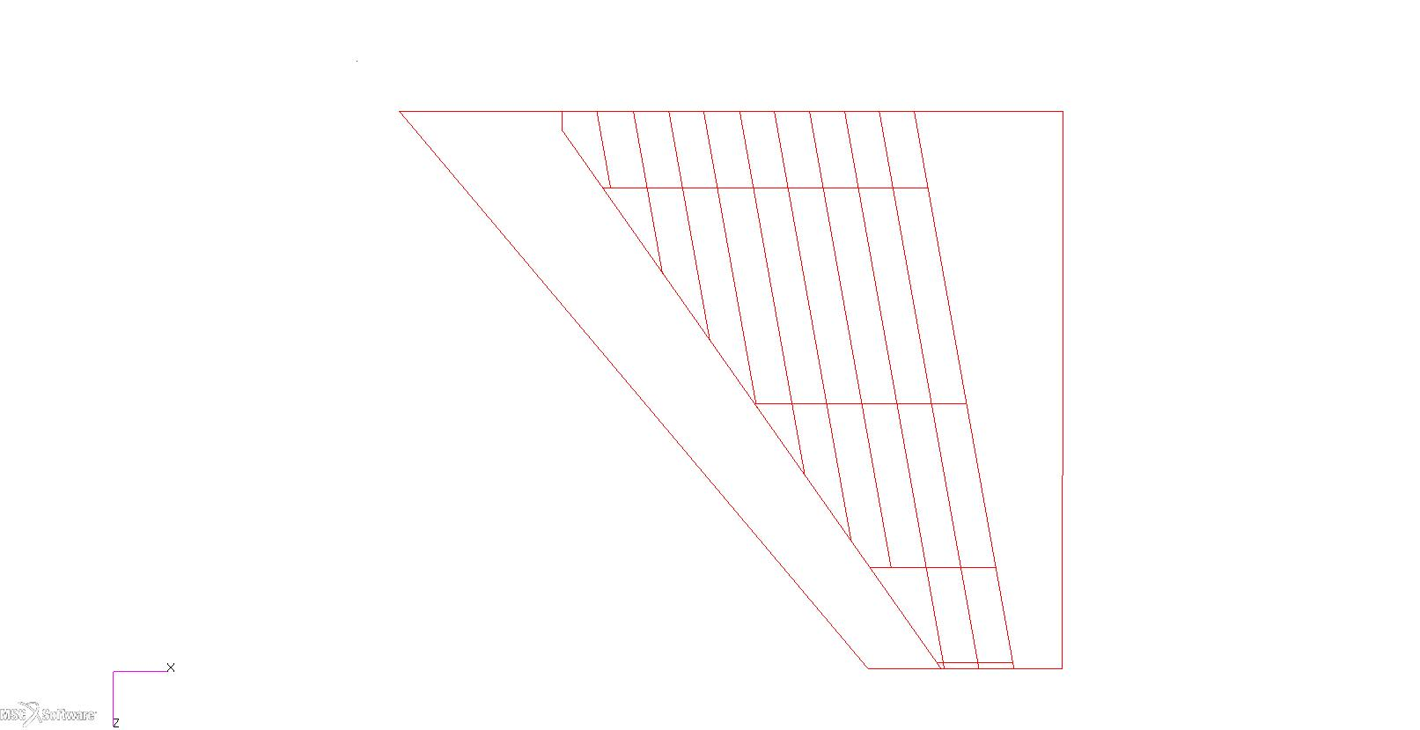
Section 4
Section 3
Section 2
Section 1
Torque box
Leading edge
(a) Actual wing structure (b) Simplified wing structure

Figure 1 Spar/rib structural lay-out of the F-16 wing

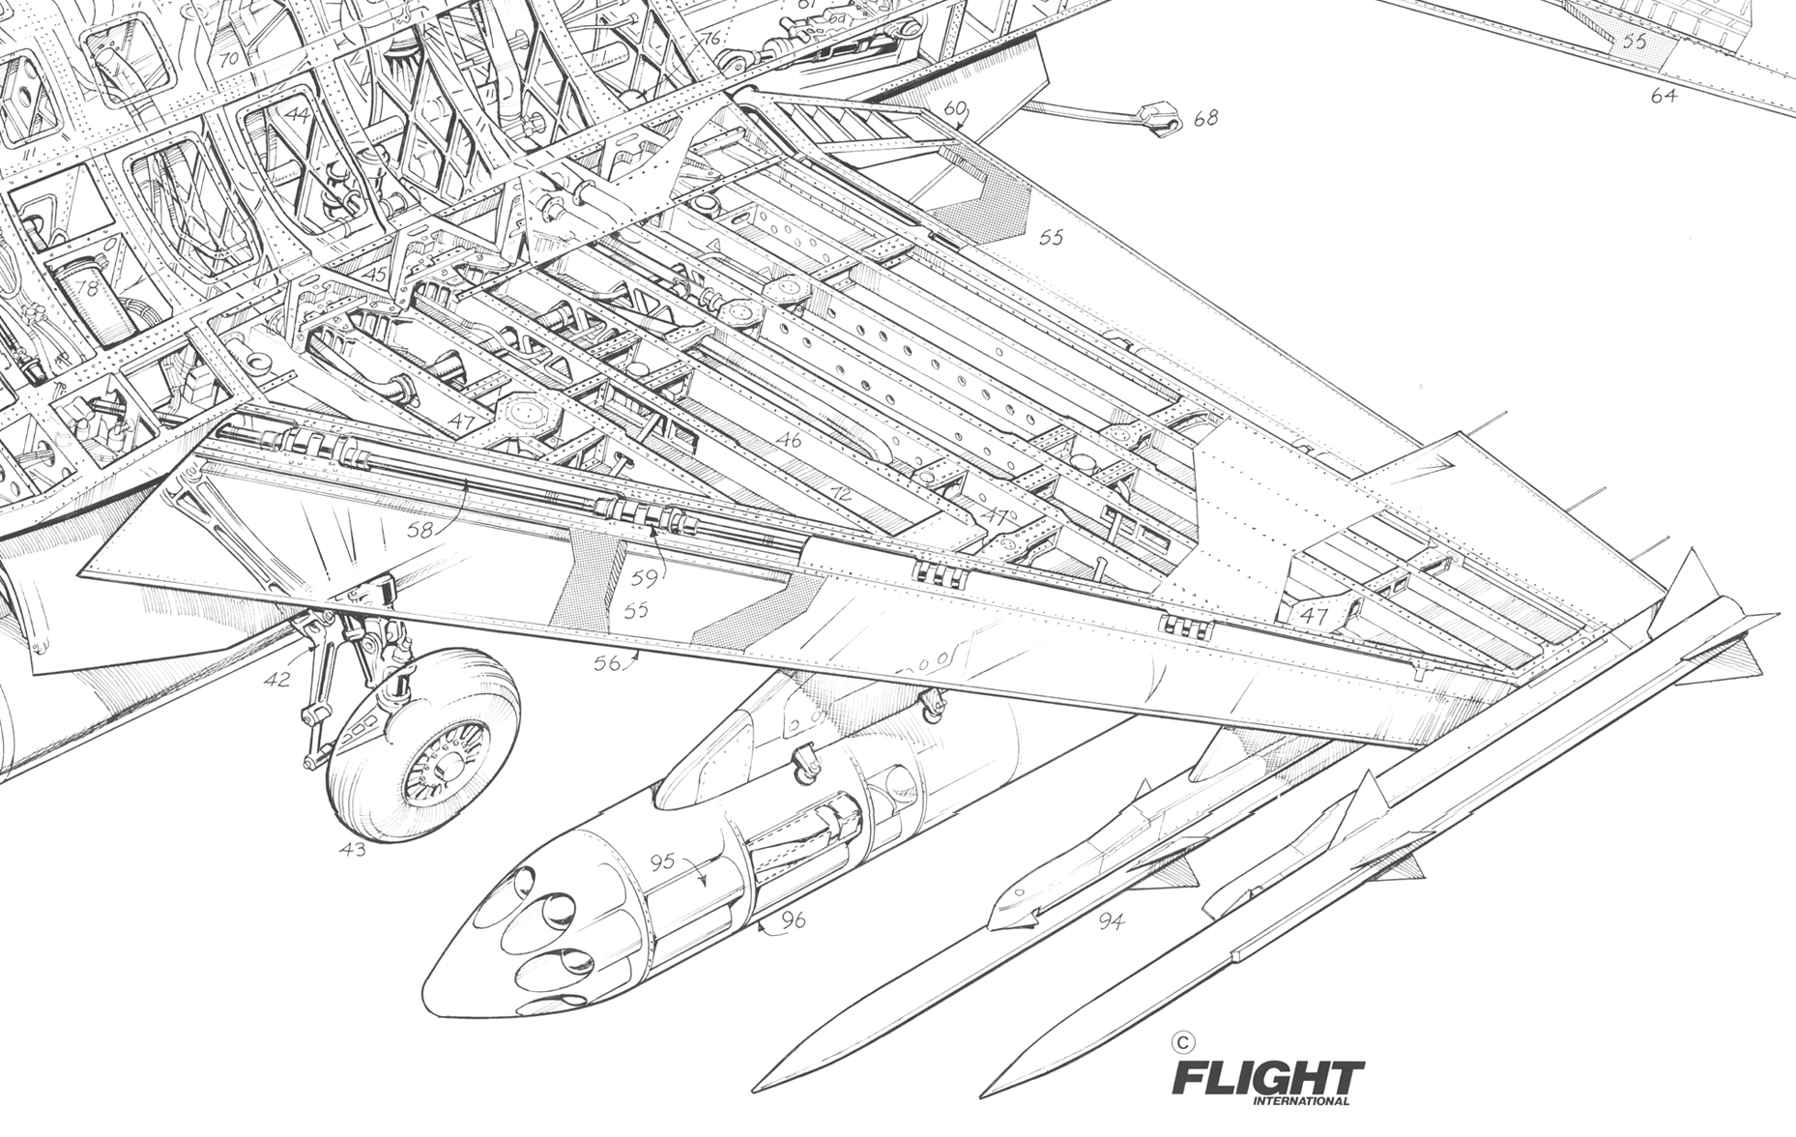
Tension fittings for root joint connection

Figure 2 Detailed internal structural lay-out of the F-16 wing
4-Design Specifications

The proposed primary structure consists of multi-cell box beams, as shown in Figure 1(b). Due to the tapered nature of the wing, the number of cells in each section increase as you go from wing tip to wing root. In this project, spar and rib locations are fixed as shown in Figure 1(b). The goal is to size the four sections shown in Fig. 1(b).

The design variables are:

- Flange areas of the spars in each section (You can size them according to the spar heights so that they more or less have equal stresses. Note that the flange areas must be reasonable.)
- Upper and lower skin thicknesses in each section
- Spar web thicknesses in each section
- Rib web thicknesses and rib flange areas (see the note for rib sizing)

You can keep the flange areas and thicknesses constant in each section and increase them discretely from section 1 to section 4. Structural analysis of the wing can be carried out at discrete sections as shown by the dash lines in Figure 3.

In the sizing calculations, try to use minimum dimensions to get minimum margin of safety. For the minimum margin of safety, you can take 0.01. Since 1.5 factor of safety is already included in the external load calculation, for minimum weight you have to aim for miminum margin of safety.

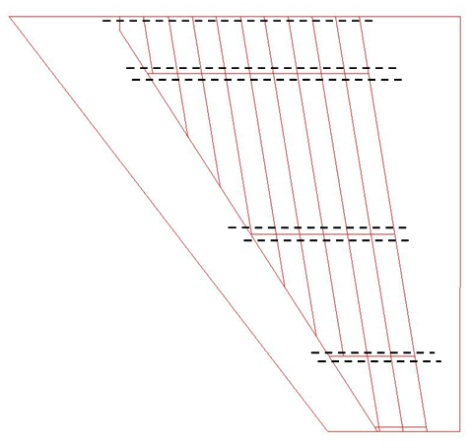
Figure 3 Structural analysis (shear flow and bending stress) calculation sections

5-General Requirements

Structural idealization:

Assume that spar flanges and stiffeners take axial load only. Spar webs and skin panels are effective in shear and axial load. Therefore, in your calculations you should include the inertia of the panels (skin panels and spar webs). Explanation about the sizing of the structural members of the wing is given under two separate headings. The first group is the spar flange, spar web thickness and skin thicknesses. The second group is the sizing of rib web thickness and rib flange area.

5.1. Sizing of spar flange, spar web thickness, skin thicknesses

Shear Flow Calculations:
In the shear flow equations, include only the inertia of the flanges in the calculation of the first moments. This way, we can get constant shear flow webs.

ex: q2=q1-VQ/I

In this equation, consider the first moment Q for flanges and for the total moment of inertia (I)
include the inertia of the flanges only in the shear flow calculations. This is our classical approach except for the fact that for the bending stress calculations use the total moment of inertia including the inertia of the flanges and web/skin panels.

Buckling Checks:
In this project, we will assume that we have buckling resistant panels (skin and spar web). Therefore, we wll not permit buckling even at the ultimate load. However, in this case to have a minimum weight wing structure, you need to size the panels such that you will have minimum positive margin of safety such as 0.01. Panel buckling (skin and spar web) will be due to combined buckling:

For the upper skin panels: combined shear + compression loading
For the lower skin panels: combined shear + tension loading
For the spar webs: combined shear + in-plane bending loading

In the buckling calculations, for the fighter wing, you can assume clamped edge conditions for the skin panels and spar webs.

Note that although the wing section is unsymmetric, you can use the symmetric bending formula in the calculation of axial stresses due to bending and in writing the shear flow equations.

Change the sizing discretely between the rib stations.

For buckling check of the panels (skins and spar webs) use the average stresses (or stresses in the middle of each rib section) in each rib section as shown in the figure below. Note that F-16 wing does not have many ribs since there are many spars. Panel lenghts of section 3 are high. So be careful !.
in-board values of stress for strength check
root
Rib i
Rib i+1
Average stresses at the mid station for buckling check

Note on buckling checks:

When checking the buckling design constraint remember that:

You need to use interactive equations for buckling checks under combined loading of the panels since we assume that panels also carry axial stress.

As for the panels, check upper and lower skin panels, spar webs and ribs. In the buckling calculations, assume that spars, ribs and stringers provide simple support conditions.

Also note that in this project, we do not consider the buckling of spar flanges. This is because the spanwise flanges or stringers are supported by the wing skin on one side. In actual cases we should check the buckling of skin-stringer combination between the spars and ribs assuming that ribs and spars provide simple support conditions.

Strength Checks:
For strength checks determine the maximum direct stresses on the spar flanges and the skin/web panels based on the in-board values of the stresses for each rib station. For the panels calculate the Von-Misses stresses using the maximum shear and axial stress for spar flanges and panels (skin/spar web) at the in-board location of each rib station.

Note that in sizing the spar flanges, you have to make sure that spar flanges possess sufficient stiffness to enforce boundary conditions for local buckling of wing skins. You need to come up with reasonable flange areas so that they provide the required edge conditions. Therefore, try to minimize skin thicknesses so that flange areas do not turn out to be very small. Remember, since in this project you are also taking the spar web and skin inertias into account, wing bending load will also be carried by the skin also. Therefore, if you increase the wing skin thicknesses, you may come up with small flange areas and thicker wing skins. You may use the following constraints on spar flanges after you determine the flange areas from strength checks.

Assuming a T shaped spar flange (see the figure below):

- Width (w) of the T should not be less than 20 times the flange thickness (tf)
- Flange height h should not be less than 16 times the flange thickness (tf)
- Flange thickness should not be less than 2 times the skin thickness of the wing at the section analyzed.

w

tf

h

tf

Note: You are encouraged to make research on the required spar flange sizes such that spar flange areas provide the required stiffness so that they provide the required edge constraint between a simply supported edge and a clamped edge.
In this part, you also need to introduce the calculations performed by presenting one sample calculation in your report.

- Margin of safety calculation for one of the spar flange at a certain wing span location for the final minimum weight configuration that you obtained.
- Calculation of shear flows in the skin and webs at a certain spanwise station for the final minimum weight configuration that you obtained. Here you also have to show the margin of safety based on the Von-Misses stress acting on the particular skin or web panel.
- Buckling constraint calculation of skin or web panels and buckling margin of safety.

Simplifications:

- Ignore the contribution of the trailing edge of the wing behind rear spar to the structural stiffness. Consider only the torque box shown in Fig. 1(b).
- For the inertia and buckling calculations, you can approximate wing as composed of straight panels between the wing spars.
- Since the internal loads are calculated for the ultimate load factor of 9g, you have to use a factor of safety of 1.5 on the ultimate strength allowable of wing material.
- Search for the materials used in the wing of F-16 aircraft. It is known that 80 percent of the airframe structure of the F-16 is of conventional aluminum alloy. Search which alloy has been used and obtain the material properties and allowables from MIL-HDBK-5H. Note that for the material allowables, you can use ultimate strength values divided by 1.5 since the external loading will be calculated for 9g.
- Select the final skin thicknesses, spar caps and other longitudinals from standard available sizes. You may refer to Bruhn, or other references such as aircraftspruce.
- You may change skin thicknesses, flange and stiffener areas discretely between the wing ribs. Do not change skin thicknesses chordwise, but you can change the flange areas and spar web thicknesses chordwise.
- The rib spacing is already given in the .igs file. Use the simplified drawing given in Fig. 1(b). thickness must be such as to maintain the basic airfoil shape, without local or global buckling of the rib and the skin longitudinal stringers.

5.2. Sizing of rib web thickness and rib flange areas

Rib web thicknesses:

Size the inter-spar rib webs based on the rib web shear stresses and the compressive stress due to Braizer loading acting on them. In this project, we assume that ribs are composed of rib web and rib flanges only without any vertical stiffener on the rib web. Since, the fighter wing is composed of multi-spar here we assume that we do not need any vertical rib stiffener.

a) Inter-spar rib web shear stresses

Determine the inter-spar rib web shear stresses by finding the reactive shear stresses coming from the outboard and inboard sections as shown in the figure given below. Since the skin and spar web thicknesses will be different in the out-board and in-board sections of the wing, there will be net reacting shear stress on the rib coming from wing skins and spar webs. Note the maximum shear stress in the inter-spar rib webs at the rib station. You can use the maximum stress in sizing the rib web thickness described below.

root
Rib i
in-board station
out-board station
Reacting shear stresses on the rib coming from in-board and out-board sections

Spar web i
Spar web i+1

b) Compressive stress due to Brazier loading while wing bends

The explanation for the Brazier loading is given in the class. Calculate the compressive load on the rib using the following formula we have derived.

$$P_{\text{rib}}=\frac{M^{2}y (\text{wt})}{{\text{EI}}^{2}}\left(\frac{L_{1}+L_{2}}{2}\right)$$

where

M: is the bending moment acting at the section of inter-spar rib
y: Distance from the neutral axis to the outer fiber measured in the section where M is
calculated
I: Second moment inertia of the wing box at the rib section
t: Skin thickness of the wing (you can take average skin thickness of the out-board and in-board section of the wing rib)
w: Inter-spar distance (width of the rib between spars)
E: Young’s modulus of the wing material
L1 & L2: Average rib spacing – defined in Figure 4 below.

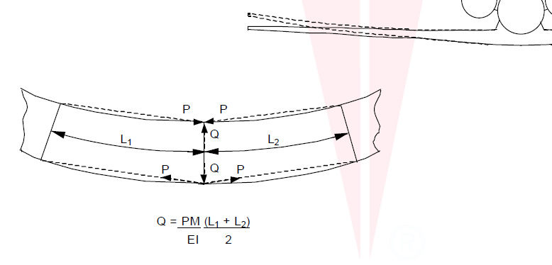
Figure 4 Brazier loads due to wing bending

For wing rib sizing use Figure 5 which shows the shear and compressive stress acting on the wing rib.

$$σ_{\text{comp}\text{.}\text{rib}}$$

Maximum reacting shear stress
in the inter-spar rib at the rib station

$$σ_{\text{comp}\text{.}\text{rib}}$$

Figure 5 Combined loading acting on the wing rib

Having determined the shear stress and compressive stress acting on the rib size the rib web by making the following strength buckling checks

- Calculate the maximum Von Misses stress on the rib and make strength check
- Check the buckling of the rib web assuming that rib web is under compression and shear loading. Therefore, you need to use interaction equations to check buckling of the rib web. In the buckling calculations you can assume clamped edge conditions in the connection of the wing rib to wing skins and spar webs.

Make sure that you make the sizing to determine minimum positive margin of safety such as 0.01.

Rib web flange:

Normally, rib web flanges must be sized based on rib bending and concentrated loads acting on the rib flange. However, in this project we will size the rib flanges such that they possess sufficient stiffness to enforce boundary conditions for local buckling of wing skins.

In this project you can approximate the rib flange area as the average of spar flange areas at the rib station. This would be reasonable assumption.

Discussion of your results:

The final section of this part should include a table summarizing the structural elements and cross-sectional areas and thicknesses etc. along with a weight break down resulting in the final weight of the wing. This part should give the summary of the structural layout calculated for the 9g load case. Your summary tables should be easy to understand. Readers should not have to guess what you have done. You should have clear headings, explanations for all the information that you want to convey.

In the discussion of your results, stress on the design weight and the iterations performed to reach the minimum design weight. Make some comparisons such as spar flange area, skin thicknesses for the designs performed by using the 9g load case. Comment on your results and see if they make sense or not.

6. Submission Documents

1. Wing loading calculation document.

Summarize the internal loads due to 9g limit load case. This is what you have done in first part of your project. Use Schrenk’s integration method to calculate the internal loads at the stations where you will do sizing.

2- Wing structural design and analysis document

The overall sizing should be decided based on the calculations that you have to report within the content of this document.
You can perform the analysis with a computer program or using excel or Matlab etc. Based on internal loads you have determined, you have to carry out iterations until you satisfy the most critical load case and obtain a wing structural lay-out with minimum weight. Do not forget that you success is directly proportional to:

- Minimum weight design
- Manufacturability and the use of standard size material

3- Project Presentation

Each team will prepare a presentation and present the key points reported in documents 1-4. The presentation of each group will be maximum 20 minutes. In their presentation the groups should stress:

- Design weight and the iterations performed to reach the minimum design weight
- Manufacturability and the use of standard size material

